|  |
| --- |
|  |
| Angular 8 |
|  |
| Angular - Component, Routing |

**TechBrain Express**

December 9, 2019

Authored by: Ashu

Component, Routing

* **Demonstrate creation of component**
* **Demonstrate routing**

**Refer:** D:\backupdt20092019_beforeformat\Revature\Angular\RevatureAngular\revatureBookStoreAddBookLogin

# Component

Components are a logical piece of code for Angular JS application. A Component consists of the following −

**Template**− This is used to render the view for the application. This contains the HTML that needs to be rendered in the application. This part also includes the binding and directives.

**Class −** This is like a class defined in any language such as C. This contains properties and methods. This has the code which is used to support the view. It is defined in TypeScript.

**Metadata**− This has the extra data defined for the Angular class. It is defined with a decorator.

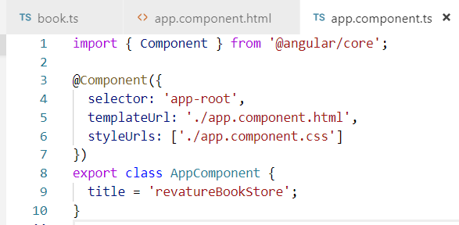

## How to create a new component

**Generate a navbar component**

Eg: > Ng g c Navbar

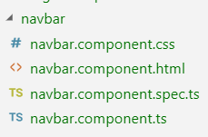

**Explain template,class, metadata**

**Template :** <https://angular.io/guide/template-syntax>

The Angular application manages what the user sees and can do, achieving this through the interaction of a component class instance (the *component*) and its user-facing template.

**Inline Template:**

template: '

<div>

<h1>{{appTitle}}</h1>

<div>To Tutorials Point</div>

</div>

**External Template:**

templateURL:

viewname.component.html

**Directive** A directive is a custom HTML element that is used to extend the power of HTML. Angular 2 has the following directives that get called as part of the BrowserModule module.

* ngif
* ngFor

Lab : Create a nav bar as follow , install boostrap, popper and jquery .



<https://getbootstrap.com/docs/4.3/components/navbar/>

1. **Create Navbar**

Navbars come with built-in support for a handful of sub-components. Choose from the following as needed:

1. .navbar-brand for your company, product, or project name.
2. .navbar-nav for a full-height and lightweight navigation (including support for dropdowns).
3. .navbar-toggler for use with our collapse plugin and other [navigation toggling](https://getbootstrap.com/docs/4.3/components/navbar/#responsive-behaviors) behaviors.
4. .form-inline for any form controls and actions.
5. .navbar-text for adding vertically centered strings of text.
6. .collapse.navbar-collapse for grouping and hiding navbar contents by a parent breakpoint.
7. Copy following code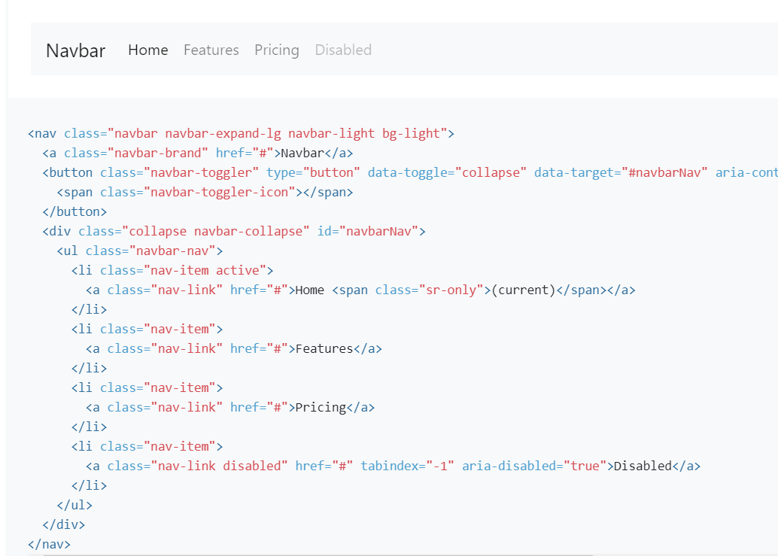

Make changes as follows:

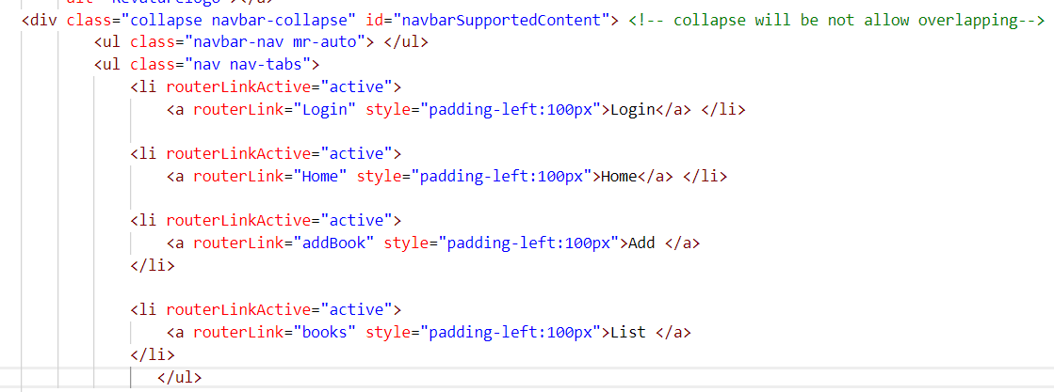

1. Update index.html index.html- <link href="https://maxcdn.bootstrapcdn.com/bootstrap/4.0.0/css/bootstrap.min.css" rel="stylesheet">
2. npm install ngx-bootstrap --save
3. npm install popper --save
4. npm install jquery --save
5. **Add Search Bar: Refer**

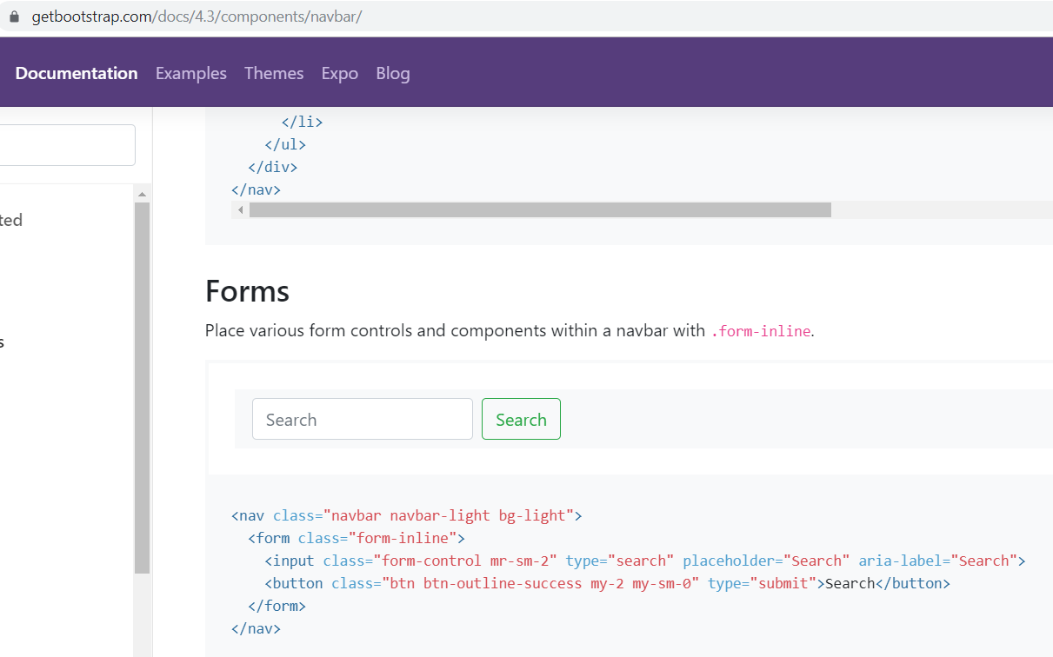

1. Update angular.json - "styles": [

"src/styles.css",

"node_modules/bootstrap/dist/css/bootstrap.min.css"

],

"scripts": [ "node_modules/jquery/dist/jquery.min.js",

"node_modules/popper.js/dist/umd/popper.min.js",

"node_modules/bootstrap/dist/js/bootstrap.min.js"]

1. **Create Logout Button**



1. **Add Logo**

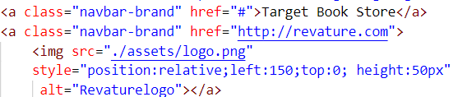

**Analyse without** class="collapse navbar-collapse" it would be like

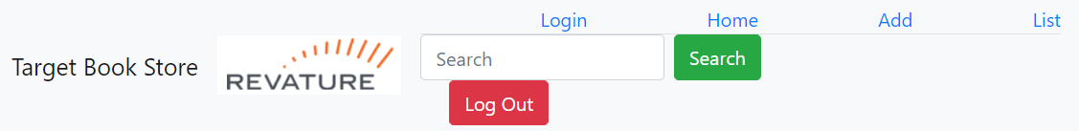

1. **FINAL CODE for navbar**
2. <!--The content below is only a placeholder and can be replaced.-->
3. <!-- NAVBAR -->
4. <div>
5. <nav class="navbar navbar-expand-sm navbar-light bg-light ">
6. <a class="navbar-brand" href="#">Target Book Store</a>
7. <a class="navbar-brand" href="http://revature.com">
8. <img src="./assets/logo.png"
9. style="position:relative;left:150;top:0; height:50px"
10. alt="Revaturelogo"></a>
11. <div class="collapse navbar-collapse" id="navbarSupportedContent"> <!-- collapse will be not allow overlapping-->
12. <ul class="navbar-nav mr-auto"> </ul>
13. <ul class="nav nav-tabs">
14. <li routerLinkActive="active">
15. <a routerLink="Login" style="padding-left:100px">Login</a> </li>
16. <li routerLinkActive="active">
17. <a routerLink="Home" style="padding-left:100px">Home</a> </li>
18. <li routerLinkActive="active">
19. <a routerLink="addBook" style="padding-left:100px">Add </a>
20. </li>
21. <li routerLinkActive="active">
22. <a routerLink="books" style="padding-left:100px">List </a>
23. </li>
24. </ul>
25. <form class="form-inline my-2 my-lg-0"> <!-- m stands for margin and y (top+bottom)-->
26. <input class="form-control mr-sm-2" type="search" placeholder="Search" >
27. <button class="btn btn-success my-2 my-sm-0" type="submit">
28. <span class="glyphicon glyphicon-search"></span>
29. Search
30. </button> </form>
31. <a href="logout">
32. <button type="button" class="btn btn-danger ml-4">Log Out</button>
33. </a>
34. </div>
35. </nav></div>
36. <router-outlet></router-outlet>

**Lab: Cerate 4 component Login, Home, Book, BookList component.**

**Demonstrate routing**

1. Make sure having home/customer/About component.

2. <nav>

<a routerLink="home" routerLinkActive="active">Home</a>

<a routerLink="about">About</a>

<a routerLink="dashboard">Dashboard</a>

</nav>

<router-outlet></router-outlet>

3. routeConfig.ts in app

import { Routes } from '@angular/router';

import { HomeComponent } from './home/home.component';

import { AboutComponent } from './about/about.component';

import { CustomerComponent } from './customer/customer.component';

export const appRoutes: Routes = [

{ path: 'Home',

component: HomeComponent

},

{

path: 'About',

component: AboutComponent

},

{ path: 'Customer',

component: CustomerComponent

}

];

export default appRoutes;

4. app.module.ts

import { appRoutes } from './routerConfig';

imports: [

BrowserModule, RouterModule.forRoot(appRoutes)

5. Add spaces in buttons

<li class="nav-item" class=span style="margin:5px;">

6. Add Search box + Login Button

1. Map component with path

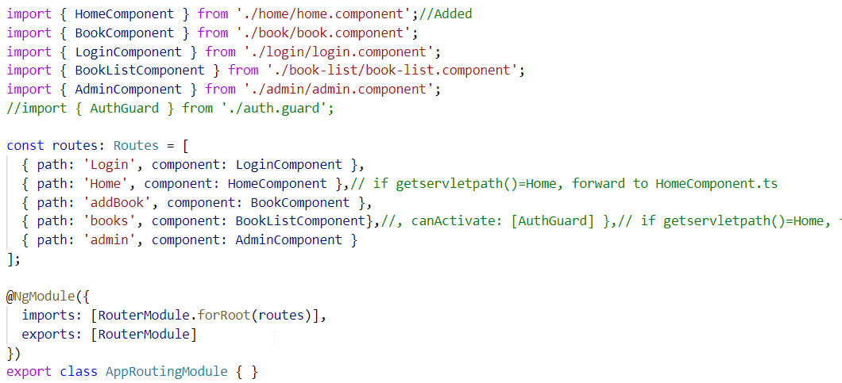

1. Make sure path the same as routerlink

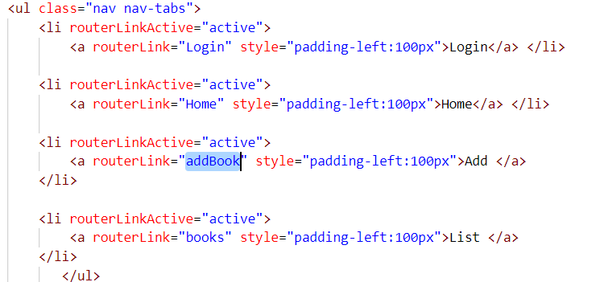

1. **Test: On click of home it must navigate to home component**

## Lab: Display company name using Interpolation.

## Lab: Declare an array of books in booklist component and display it in booklist.component.html

1. Open BookListComponent.ts

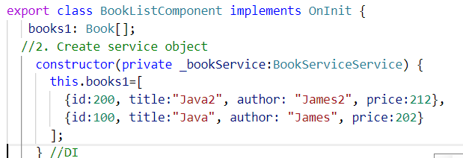

2. Open BookListComponent.html

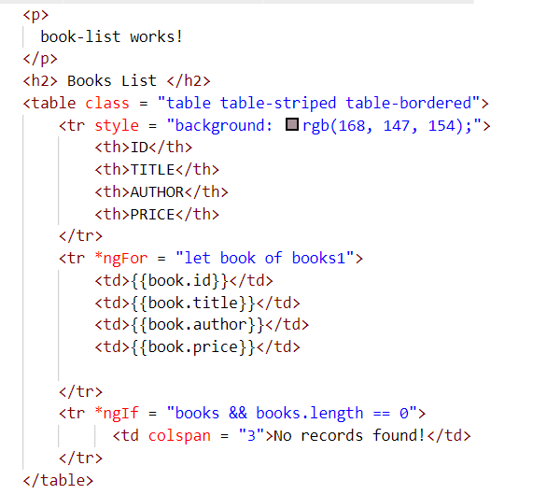

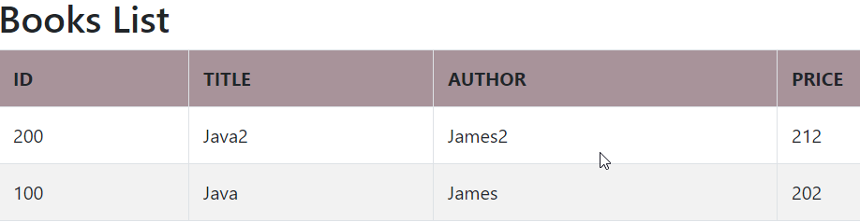

**Demonstrate event handling and two way binding**